WEEK 1: Project Review and Development Planning

INTENDED LEARNING OUTCOME
At the end of this activity, students should be able to:
Develop a comprehensive project implementation plan by reviewing the approved capstone proposal, validating project scope, incorporating panel recommendations, assigning project responsibilities, preparing a project schedule, and establishing project monitoring tools.

OVERVIEW OF WEEK 1 OUTPUTS
By the end of Week 1, each group must submit:
- Panel Recommendation Compliance Matrix
- Project Scope Validation Form
- Work Breakdown Structure (WBS)
- Revised Gantt Chart
- Project Development Plan
- Repository Setup Report
- Adviser Consultation Record

ACTIVITY 1
Review of Panel Recommendations

Purpose
To ensure that all recommendations from the proposal defense have been reviewed and addressed before implementation begins.

Procedure
- Secure a copy of the proposal defense evaluation sheet.
- Review all comments from the panel.
- Discuss as a group how each recommendation will be addressed.
- Complete Form 1.

FORM 1
PANEL RECOMMENDATION COMPLIANCE MATRIX

Instructions
For every recommendation:
- Copy the recommendation exactly as stated by the panel.
- Describe the action that the group will take.
- Identify supporting evidence.
- Mark the status.

No. | Panel Recommendation | Planned Action | Evidence | Status
 | Lack of empirical grounding, weak local situational analysis, insufficient discussion of existing systems, and overly lengthy and repetitive discussion of communication delays and manual processes with limited emphasis on technological and system-related gaps. | Revised the Project Context by incorporating relevant studies, strengthening the local disaster situation analysis in Echague, discussing existing disaster communication systems and limitations, reducing repetitive discussions, and emphasizing technological and system-related gaps. | Updated Chapter 1 – Project Context by incorporating empirical studies, strengthening the local situational analysis, discussing existing disaster communication systems, and streamlining repetitive discussions. | Completed
 | Questions were solution-driven rather than problem-focused, overly evaluation-oriented, lacked measurable indicators and baseline comparisons, had weak empirical grounding, and showed inconsistencies between identified operational problems and proposed system functionalities. | Revised the Statement of the Problem by restructuring the research questions to focus on actual communication, coordination, and data management problems, integrating empirical support, measurable indicators, baseline comparisons, and strengthening alignment between operational issues and proposed system functionalities. | Updated the Statement of the Problem by revising the research questions, incorporating empirical support and measurable indicators, and aligning proposed system functionalities with identified operational problems. | Completed
 | Objectives were too broad, not measurable, feature-based, weakly aligned with the problem statement, and focused excessively on evaluation metrics rather than software development objectives. | Revised the objectives to become specific, measurable, outcome-based, and balanced between software development objectives and system evaluation while emphasizing system design, architecture, feature integration, and implementation. | Updated the Objectives of the Study by refining the objectives to emphasize software development goals, implementation, and ISO/IEC 25010-based evaluation. | Completed
 | Scope lacked clear technical and operational boundaries, included methodology-related discussions, contained weak security explanations, incomplete limitations, and unclear evaluation sampling. | Revised the Scope and Limitations by defining technical and operational boundaries, removing methodology-related discussions, strengthening security explanations, clarifying evaluation coverage, and reclassifying future enhancements. | Updated the Scope and Limitations by clarifying technical and operational boundaries, strengthening security discussions, refining limitations, and identifying future enhancements. | Completed
 | Benefits were too general, academic contribution was weak, stakeholder coverage was limited, and discussion of contributions to e-governance and ICT innovation was insufficient. | Revised the Significance of the Study by strengthening stakeholder-specific contributions, emphasizing e-governance and ICT innovation, and highlighting academic and practical relevance. | Updated the Significance of the Study by strengthening stakeholder-specific contributions, academic relevance, and discussions on e-governance and ICT innovation. | Completed
 | Chapter III / Research Methodology – Research methodology lacked methodological depth, supporting references, and research focus, while discussions were overly lengthy, repetitive, and contained technical content more appropriate for Chapter IV. | Revised Chapter III by strengthening methodological discussions with supporting literature, improving the developmental research approach, integrating the IPO model, streamlining repetitive discussions, and separating research methodology from technical system descriptions. | Revised Chapter III by strengthening the research methodology, integrating supporting references and the IPO model, and removing repetitive technical discussions. | Completed
 | Lacked justification for selecting RAD, comparison with other SDLC models, detailed discussion of iterative development, technical development process, and risks or limitations. | Revised the System Development Model by justifying the selection of RAD, comparing it with Agile and Waterfall, expanding the Rapid Construction discussion, and including implementation risks and mitigation strategies. | Updated the System Development Model by enhancing the justification for RAD, expanding the Rapid Construction discussion, comparing SDLC models, and identifying implementation risks. | Completed
 | Sample size justification, sampling procedures, inclusion/exclusion criteria, ethical considerations, and IT validator roles required stronger methodological support. | Revised the Participants section by strengthening sample size justification, clarifying purposive sampling, defining inclusion and exclusion criteria, expanding ethical considerations, and explaining the role of IT validators. | Updated the Participants and Sampling section by strengthening the sampling rationale, respondent criteria, ethical considerations, and the role of IT validators. | Completed
 | Lacked validation procedures, operationalization of quality characteristics, sample questionnaire items, and rigorous security evaluation. | Revised the data gathering instrument by operationalizing ISO/IEC 25010 characteristics, improving conceptual consistency, adding questionnaire items, defining Likert-scale interpretation, and strengthening the discussion of security evaluation and technical testing approaches. | Updated the Data Gathering Instrument by refining the operationalization of ISO/IEC 25010, improving the questionnaire, and strengthening the security evaluation discussion. | Completed
 | Evaluation procedures lacked structured implementation, timelines, success indicators, software engineering rigor, detailed test cases, acceptance criteria, bug tracking procedures, and measurable benchmarks. | Revised the evaluation and testing procedures by establishing structured implementation phases, defining success indicators, improving testing methodology, specifying test cases, acceptance thresholds, bug tracking, and performance benchmarks. | Updated the Evaluation Procedure and System Testing by incorporating a structured testing framework, acceptance criteria, validation procedures, and performance benchmarks. | Completed
 | Data Analysis Techniques – Relied heavily on weighted mean, lacked statistical justification, qualitative analysis procedures, analytical computations, and clear interpretation of evaluation benchmarks. | Revised the Data Analysis section by strengthening statistical justification, incorporating additional descriptive analyses, defining analytical computations, improving benchmark interpretation, and integrating thematic analysis for qualitative responses. | Updated the Data Analysis Techniques by strengthening statistical justification, analytical procedures, benchmark interpretation, and qualitative data analysis. | Completed
 | Technical workflows, data flow, security protocols, operational scenarios, testing procedures, and inter-layer communication required stronger technical explanation. | Revised the technical framework and system architecture by strengthening three-layer architecture, data flow, security implementation, REST API communication, authentication, encryption, operational scenarios, testing procedures, and traceability documentation. | Updated the Technical Framework and System Architecture by enhancing system workflows, data flow, security mechanisms, API communication, testing summaries, and the Requirements Traceability Matrix. | Completed
 | Component descriptions, technologies, programming languages, database management, development tools, hosting environment, design considerations, mock-ups, and system diagrams required stronger technical justification and explanation. | Revised Chapter IV by standardizing system component discussions, strengthening technology justifications, mapping programming languages to system layers, improving database design, explaining development workflow, enhancing hosting and security discussions, refining design considerations, and providing comprehensive explanations of mock-ups and system diagrams. | Updated Chapter IV by enhancing the discussions on system components, technologies, database design, development tools, hosting platform, design considerations, mock-ups, Context Diagram, Data Flow Diagram, and Entity-Relationship Diagram. | Completed

ACTIVITY 2
Project Scope Validation

Purpose
To verify that the approved project remains feasible and aligned with client requirements.
Procedure
- Review Chapter 1 and Chapter 3.
- Verify all objectives.
- Review scope and limitations.
- Identify any requested modifications.
- Complete Form 2.

FORM 2
PROJECT SCOPE VALIDATION FORM

Instructions
Check whether each component remains valid.

A. Objectives Validation
Objective | Still Applicable? | Remarks
- To design and develop a centralized system architecture that integrates a web-based dashboard and a mobile application to improve service request processing by:  - reducing average processing time by at least 30%, and  - achieving at least 90% task completion rate within the expected time frame. | Yes | Remains aligned with the revised project scope and continues to support the system's primary objective of improving service request processing.
- To implement an SMS Gateway integration as a redundant communication framework for low-connectivity areas, aiming for:  · at least 95% successful delivery rate,  · 98% correct recipient targeting, and  · 90% on-time delivery. | Yes | Remains aligned with the revised project scope and continues to support reliable emergency communication in areas with limited internet connectivity.
- To implement multi-factor authentication (MFA) to enhance system security by protecting sensitive resident data and preventing unauthorized access. | Yes | Remains applicable as it strengthens system security and safeguards sensitive user information through enhanced authentication mechanisms.
- To develop a Data Analytics and Reporting module that converts raw request data into structured insights, targeting at least 95% data accuracy across categories when compared to actual MDRRMO records. | Yes | Remains relevant as it supports data-driven decision-making by providing accurate and organized reports for MDRRMO operations.
- To assess the information quality of offline safety materials in the mobile application in terms of accuracy, relevance, completeness, and clarity. | Yes | Remains applicable to ensure that the offline safety materials provide reliable, relevant, and understandable information for end users.
- To determine functional performance and acceptability of the developed system based on ISO/IEC 25010 quality characteristics, aiming for an overall mean rating of at least 4.0 out of 5 across:  - functional suitability  - compatibility  - interaction capability  - security  - flexibility | Yes
  Remains aligned with the project's evaluation framework by assessing the developed system against the selected ISO/IEC 25010 quality characteristics.

B. Requirements Validation
Requirement | Validated | Remarks
Functional Requirements | □
Non-Functional Requirements | □
User Requirements | □
Hardware Requirements | □
Software Requirements | □

C. Scope Changes
List proposed modifications.
Proposed Change | Reason | Adviser Approval
Scope for the participants/respondents specifically in choosing Barangays | To narrow the coverage of the study, making the participant selection more focused and manageable within the project's development and evaluation timeline.
Revision of the project title | To make the project title more specific, concise, and reflective of the actual scope, objectives, and functionalities of the proposed system.

ACTIVITY 3
Work Breakdown Structure Development

Purpose
To organize all project activities and distribute responsibilities among team members.

Procedure
- List all tasks needed to complete the project.
- Group similar tasks together.
- Assign responsible members.
- Estimate completion dates.
- Complete Form 3.

FORM 3
WORK BREAKDOWN STRUCTURE (WBS)

Instructions
Break down project activities into smaller work packages.

Major Deliverable | Task | Assigned Member | Due Week
Front-End Development | Admin panel login interface (Vue.js / Vuetify) | Jilmar Ferrer | W2
Front-End Development | Dashboard analytics with Leaflet choropleth map and Chart.js reports | Jilmar Ferrer | W4
Front-End Development | Resident-facing mobile application screens | Eduard De Belen | W5
Back-End Development | Authentication module (Laravel Sanctum with OTP verification) | Jilmar Ferrer | W2
Back-End Development | Service request and equipment borrowing API modules | Jilmar Ferrer | W4
Back-End Development | SMS notification integration (SkySMS bulk API) | Jilmar Ferrer | W6
Database Development | Database schema design and migrations | Jilmar Ferrer | W2
Database Development | Seeder preparation for barangay and resident records | Jilmar Ferrer | W3
Security Implementation | Security audit and remediation (access control, rate limiting, CORS, file storage) | Jilmar Ferrer | W7
Testing | Unit testing of backend endpoints | Jilmar Ferrer | W9
Testing | Integration testing and user acceptance testing with MDRRMO | All members | W12
Deployment | Cloud migration and production hosting setup | Jilmar Ferrer | W13
Documentation | Technical documentation and user manual | All members | W15

Team Verification
All members must sign below:
1. _________________________
Jilmar Caesar D. Ferrer
2. _________________________
Eduard Joseph B. De Belen
3. _________________________
Jamby Villarta

ACTIVITY 4
Gantt Chart Preparation

Purpose
To establish a semester-long implementation schedule.

Procedure
- Use the completed WBS.
- Identify project milestones.
- Assign target weeks.
- Prepare the schedule.
- Complete Form 4.

FORM 4
GANTT CHART SUBMISSION FORM
Instructions
Indicate when each task will be performed.
Activities | W1 | W2 | W3 | W4 | W5 | W6 | W7 | W8 | W9 | W10 | W11 | W12 | W13 | W14 | W15 | W16 | W17 | W18
Development
Testing
Deployment
Evaluation
Documentation

Milestone Schedule
Milestone | Target Week
Alpha Version | Week 6
Prototype Presentation | Week 8
Beta Version | Week 11
Agency Immersion (MDRRMO Echague) | Week 12
Deployment | Week 14
Evaluation | Week 15
Mock Defense | Week 16
Final Defense | Week 18

ACTIVITY 5
Development Planning

Purpose
To prepare the overall implementation strategy.
Procedure
- Determine development methodology.
- Identify technologies.
- Assign project roles.
- Identify risks.
- Complete Form 5.

FORM 5
PROJECT DEVELOPMENT PLAN

A. Team Roles
Team Member | Role | Responsibilities
Jilmar Caesar D. Ferrer | Backend and Web Front-End Developer / Project Lead | Laravel REST API development, database design and migrations, Vue.js and Vuetify web administration panel, security implementation, deployment and hosting
Eduard Joseph B. De Belen | Mobile Developer | Resident-facing mobile application development, consumption of backend APIs, mobile user interface and experience
Jamby Villarta | Documenter / Client Liaison | Technical documentation and user manual preparation, recording of prototype validation sessions with the MDRRMO, coordination of adviser and client consultations, preparation of test cases and defect logs

B. Development Methodology
☑ Rapid Application Development (RAD)
□ Agile
□ Scrum
□ Waterfall
□ Incremental

C. Development Tools
Category | Tool
Programming Language | PHP 8.2, JavaScript / TypeScript
Framework | Laravel (backend REST API), Vue.js 3 with Vuetify (web admin panel)
Database | MySQL / MariaDB (XAMPP local environment)
IDE | Visual Studio Code
Repository | Git and GitHub — BOXCUBE06/SERBIS_prototype

D. Risk Management Plan
Risk | Probability | Impact | Mitigation
Unstable internet connectivity in the target barangays limits access to the system | High | High | Provide SMS-based notification as a fallback channel and design lightweight interfaces suited to low-bandwidth connections
Loss of source code or local development data | Medium | High | Commit changes to Git regularly and push to the remote GitHub repository; perform scheduled database backups
Security vulnerabilities exposing resident personal information | Medium | High | Conduct scheduled security audits and enforce access control checks, request rate limiting, and private file storage for sensitive documents
Scope creep arising from additional requests by the MDRRMO | Medium | Medium | Require adviser approval for all scope changes and maintain a documented change request log
Delays in client availability for prototype validation, which may stall the next RAD iteration | Medium | High | Schedule validation sessions well in advance, prepare asynchronous feedback forms, and proceed with independent modules while awaiting client confirmation
Team member unavailability due to academic workload | Medium | Medium | Document all modules thoroughly and maintain shared repository access so tasks can be reassigned

E. Communication Plan
Activity | Schedule
Team Meeting | Every Monday and Thursday, 4:00 PM (online)
Adviser Consultation | Every Friday, 2:00 PM, or as scheduled by the adviser
Client Coordination | Every two weeks with MDRRMO Echague (on-site visit or scheduled call)

ACTIVITY 6
Repository Setup

Purpose
To establish version control and project collaboration mechanisms.
Procedure
- Create repository.
- Create project folder structure.
- Add all members.
- Commit initial files.
- Complete Form 6.

FORM 6
REPOSITORY SETUP REPORT

Repository Information
Repository Name: SERBIS_prototype
Repository URL: https://github.com/BOXCUBE06/SERBIS_prototype

Member Access
Member | Access Granted
Jilmar Caesar D. Ferrer (Repository Owner) | Yes
Eduard Joseph B. De Belen | Yes
Jamby Villarta | Yes

Required Screenshots
Attach:
□ Repository Homepage
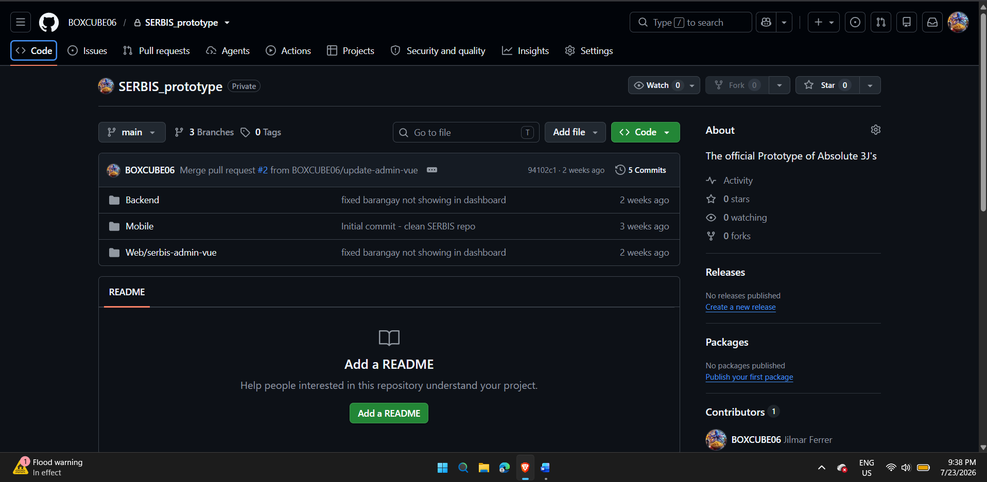
□ Team Members
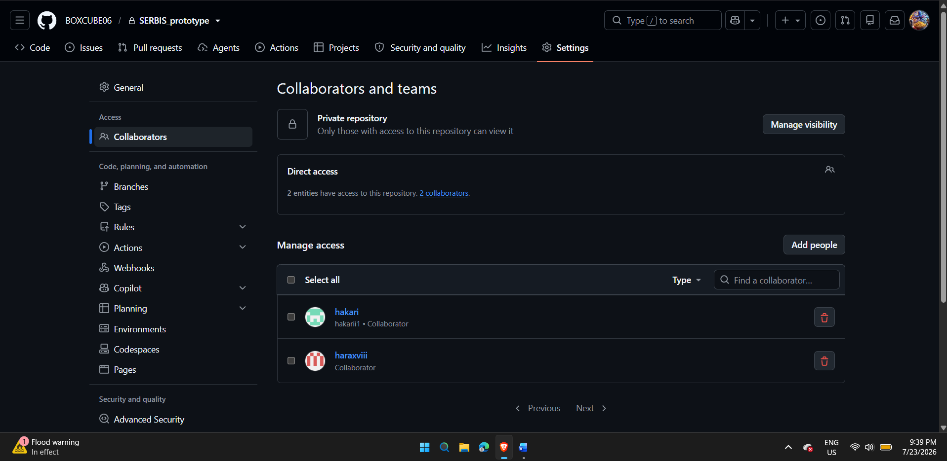

□ Folder Structure
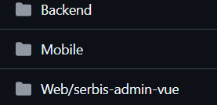

□ Initial Commit

Repository Structure
List folders created.
Folder Name | Purpose
/Backend | Laravel REST API — models, controllers, routes, migrations, seeders, and server-side application logic
/Web/serbis-admin-vue | Vue.js and Vuetify web administration panel for MDRRMO personnel
/Mobile | Resident-facing mobile application source code (maintained by the mobile developer)

ACTIVITY 7
Adviser Consultation

Purpose
To validate project readiness before development starts.

Procedure
- Present all Week 1 outputs.
- Discuss project schedule.
- Discuss risks and responsibilities.
- Record adviser recommendations.
- Complete Form 7.

FORM 7
ADVISER CONSULTATION RECORD
Date | Topics Discussed | Adviser Recommendations | Action Items

Consultation Checklist
Item | Discussed
Project Scope | □
Timeline | □
Team Responsibilities | □
Development Tools | □
Risks | □
Repository Setup | □

Adviser Approval
Adviser Name:
Signature:
Date:

